Garrett Hurd
ECEN 4517
Experiment 1

PV Panel Circuit Modeling and Circuit Simulation
Step 1:
STC:
$P_{MPP}=85 W$ $P_{in}=A*E$
$$A= \frac{1200 mm* 527 mm}{{(1000mm)}^{2}}=0.6324 m^{2}$$
$P_{in}=0.6323*1000=632.4 W$
$η= \frac{P_{MPP}}{P_{in}}= \frac{85}{632.4}*100=13.4\%$
NOTC:
$P_{MPP}=63 W$ $P_{in}=A*E$
$$A= \frac{1200 mm* 527 mm}{{(1000mm)}^{2}}=0.6324 m^{2}$$
$P_{in}=0.6323*800=505.9 W$
$η= \frac{P_{MPP}}{P_{in}}= \frac{63}{505.9}*100=12.5\%$

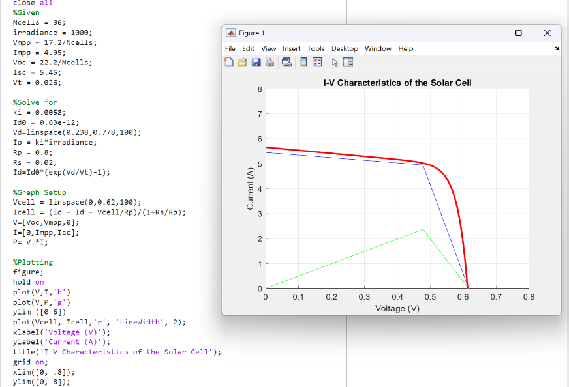
Step 2:
- To the right is the Matlab script I wrote. I typed in the given values from the datasheet. From there, I did a lot of trial and error to find the values of ki, ID0, Rp, and Rs. After finding those values, I plotted them on an I-V curve and got a plot like the one given in lecture.

- ki = 0.0058
ID0 = 0.63 * 10^-12
Rp = 0.8
Rs = 0.02

Step 3:

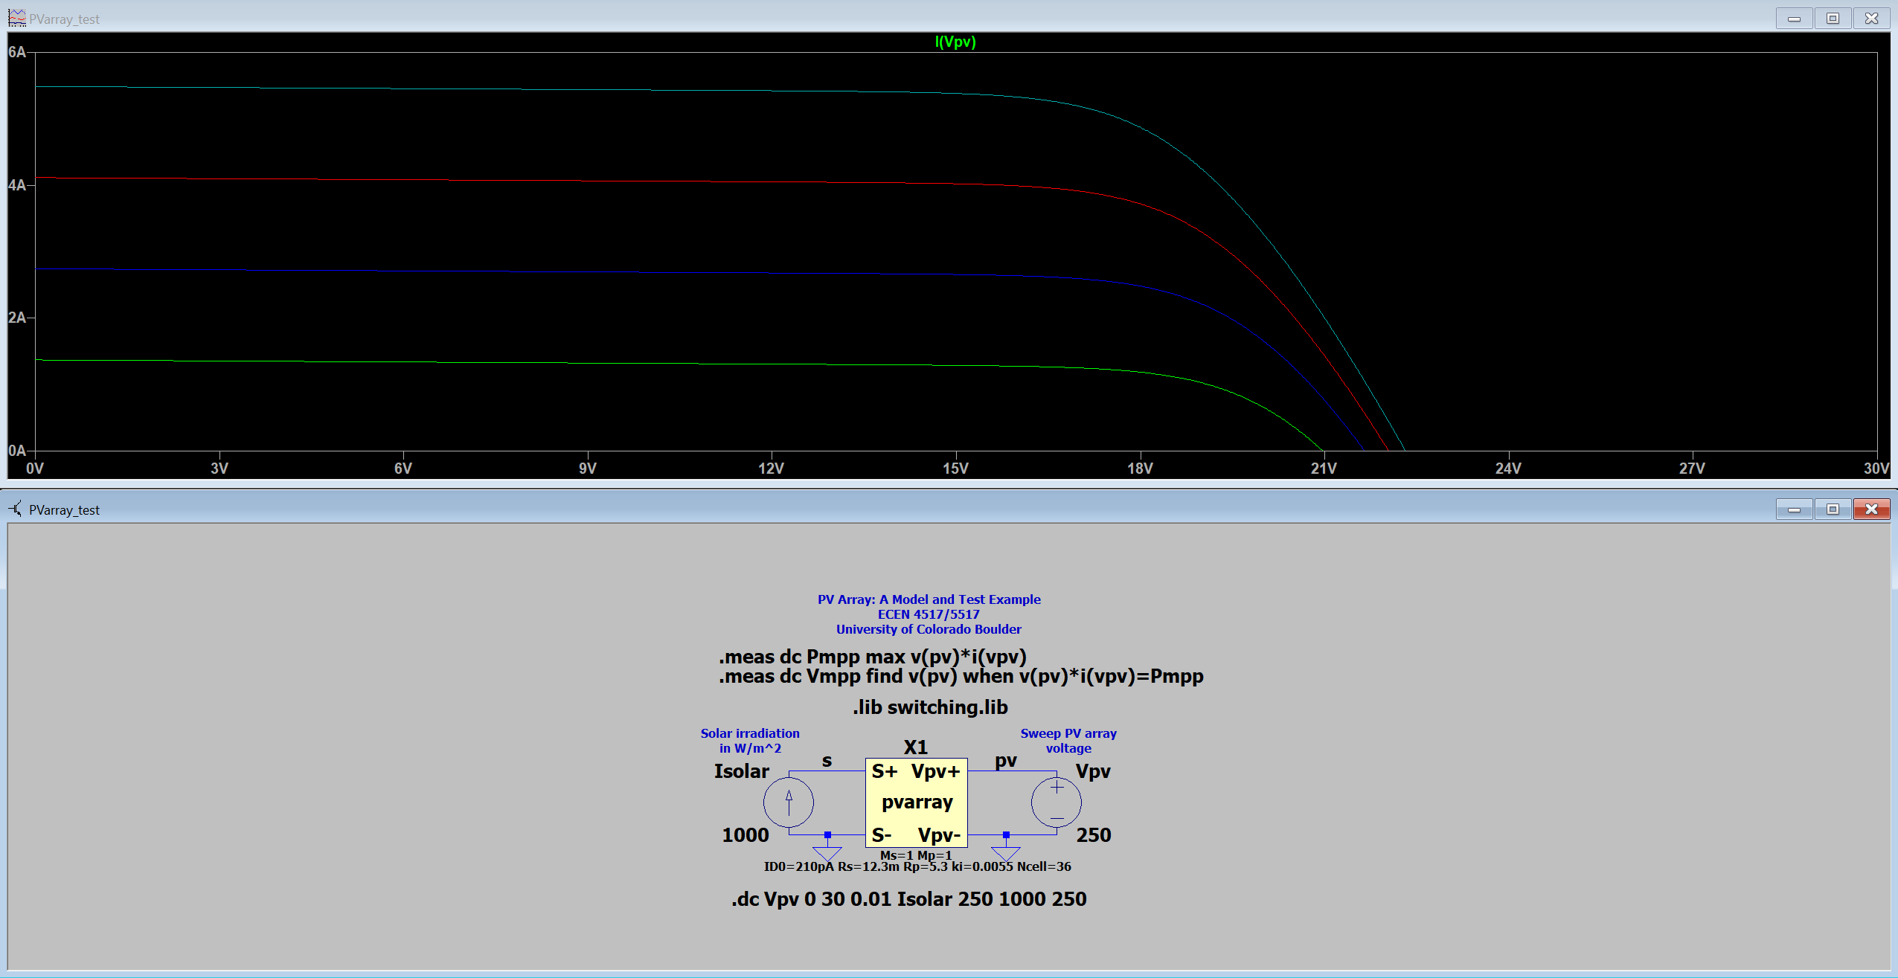
Above are the i-v curves and schematic. The top curve is the 1000 W/m^2 irradiance, followed by 750 W/m^2, 500 W/m^2, and 250 W/m^2.
I would like to note that the parameters I put into the circuit model do not match my Matlab results. This is mainly because when I used my results from Matlab in LTSpice, the i-v curves were not the result I expected. So, I did a lot of trial and error of different values to get the results above. These curves are as close I can get to the expected results. The curves should converge around the short circuit voltage of 22.2 volts.

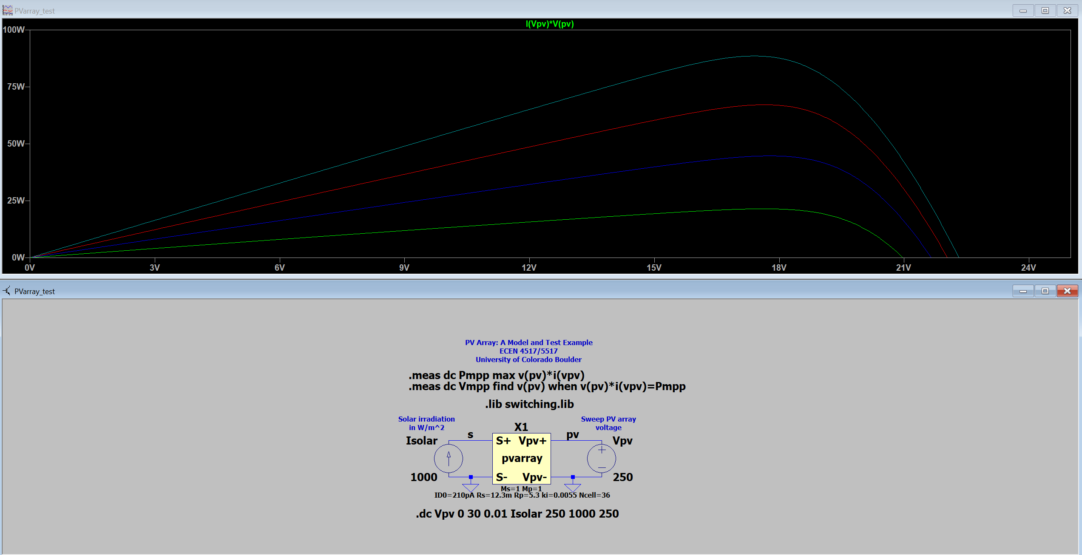
Based on the parameters I set, above are the p-v curves and schematic. Again, the top curve is the 1000 W/m^2 irradiance, followed by 750 W/m^2, 500 W/m^2, and 250 W/m^2.
ii)
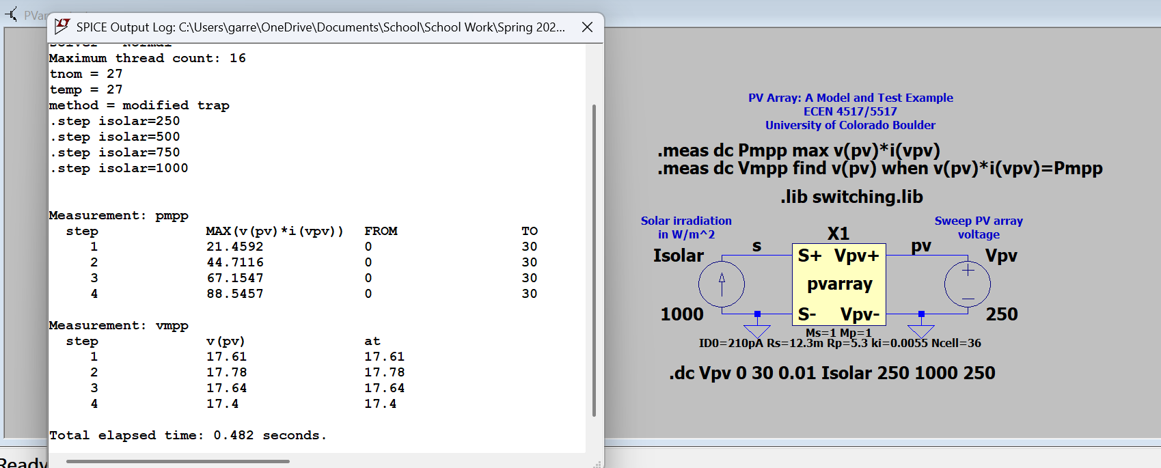
Above are the Max Power Points of the four solar irradiances. Based on the parameters I set in the circuit model, these values aren’t exact. For example, for the max power point for power should be 85 W. However, based on my parameters I got 88 W. This is close, but not what was to be expected.
Again, most of these results are off mainly because of the process I did in Step 2.

Standalone PV System Circuit Simulations
Step 4:
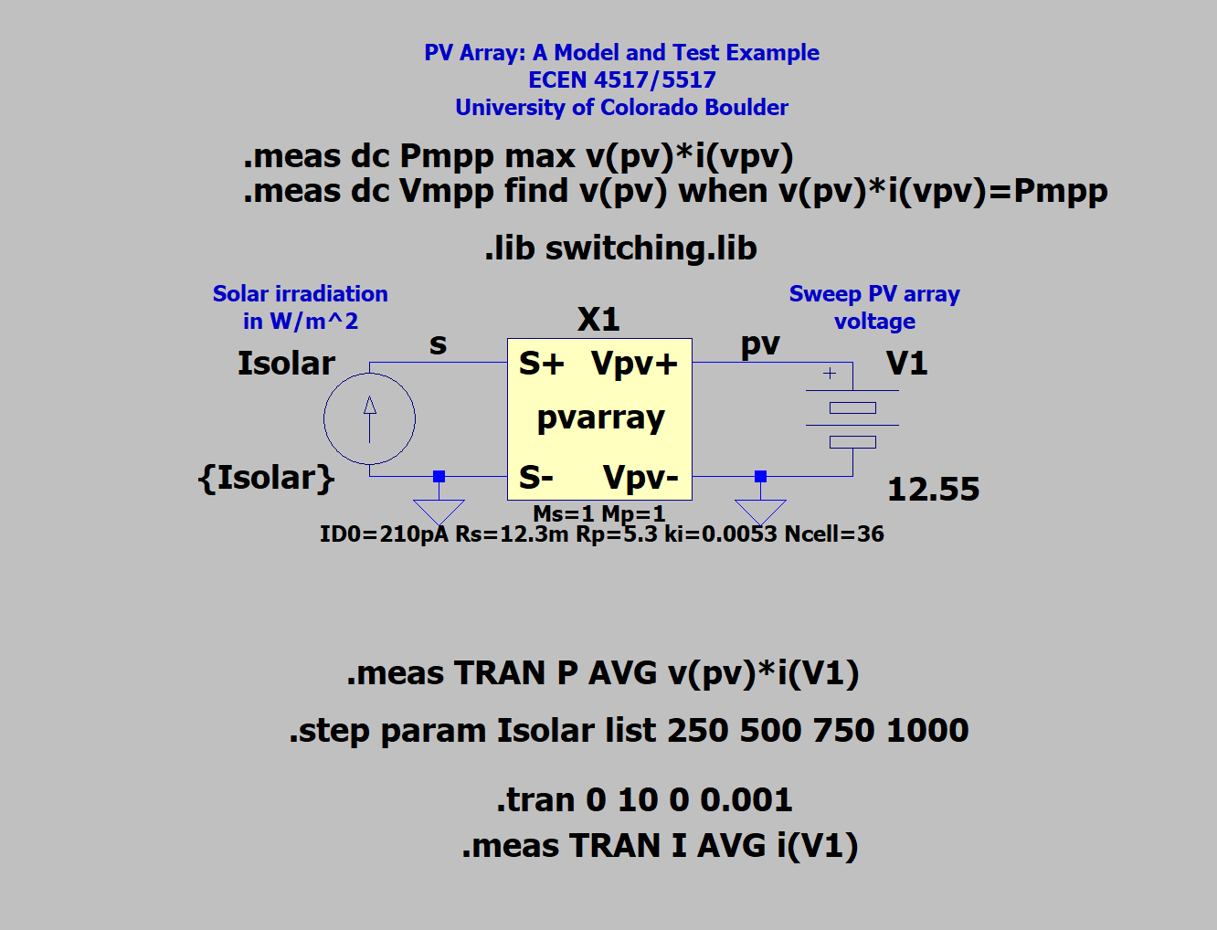

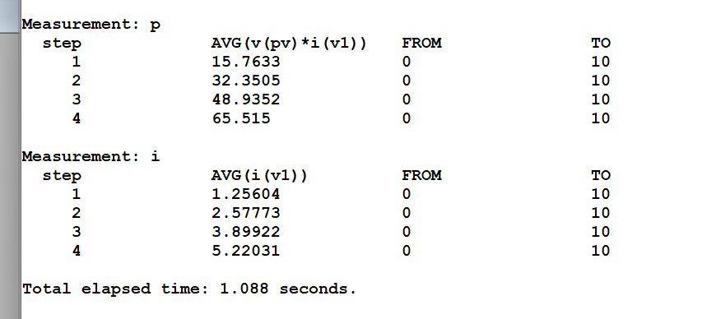
Above are the results of Ibatt and Pbatt for the four irradiance values at the parameters I set.

Step 5:

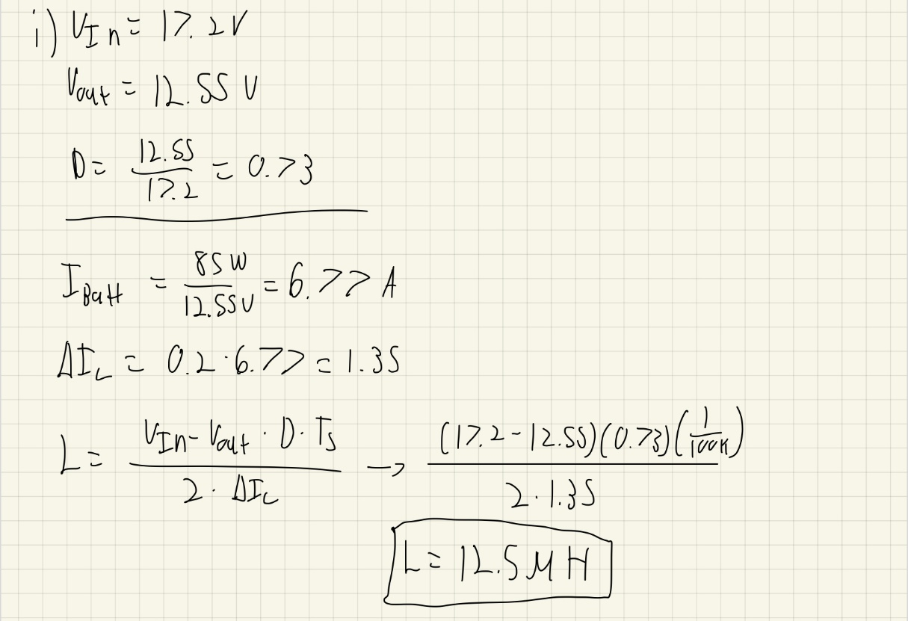
Here are my calculations for finding the duty cycle and the inductance value for the circuit below.

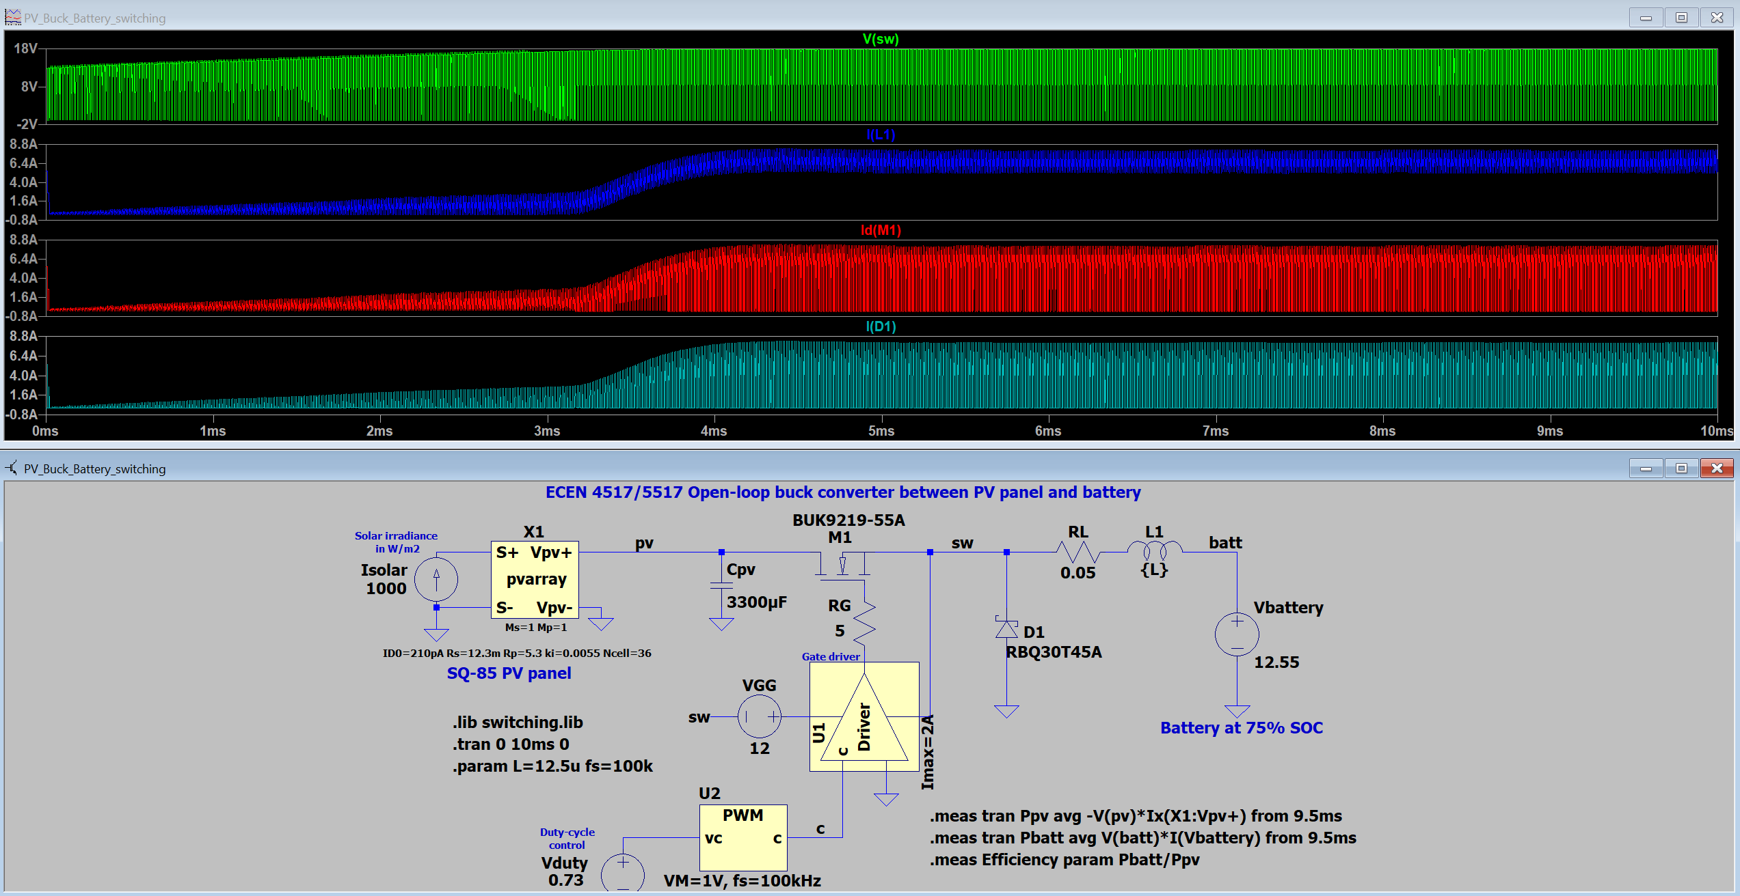
Quick note, when running this simulation there was an error with the diode model.

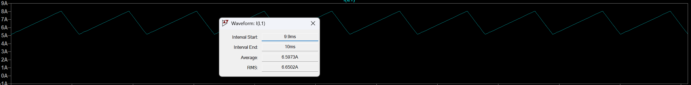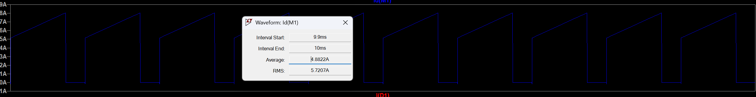
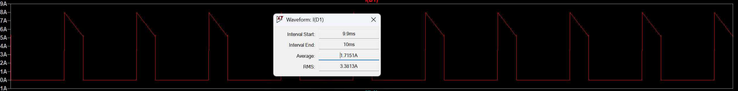
Above the simulation RMS values of the MOSFET, diode, and the inductor.

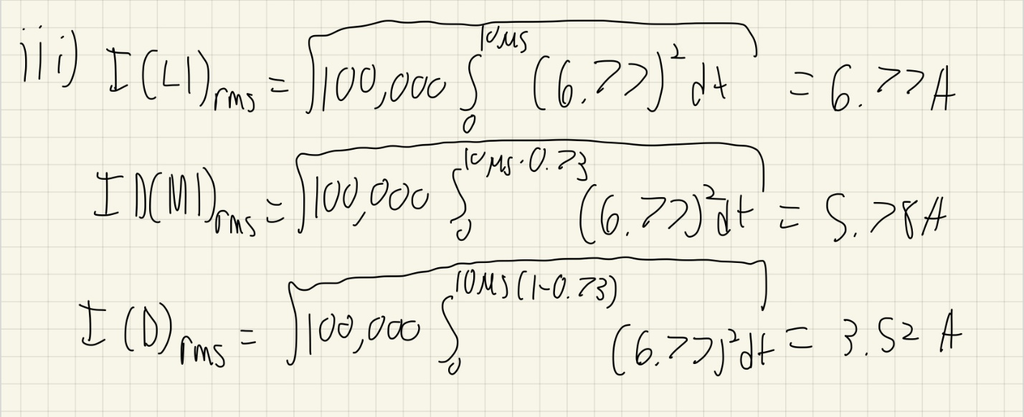
Here are my calculations for the RMS values. My results are similar to the simulation calculated RMS values.

Step 6:

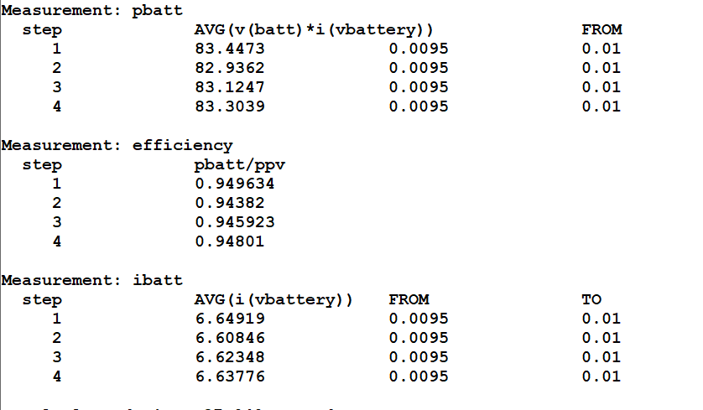

Above are my measurements of four sets of Ibatt, Pbatt, and the efficiency at different solar irradiances. I did not add Vduty mainly because I assumed that the duty cycle of 73% would remain constant at the different solar irradiances. These values are also using the same parameters I set in the PV cell from steps 3 to 5, so these values might be slightly off. However, the efficiency is 94% at each step so I am happy with that result.

Getting Started with the TMS320F28027 LaunchPad
Step 8:
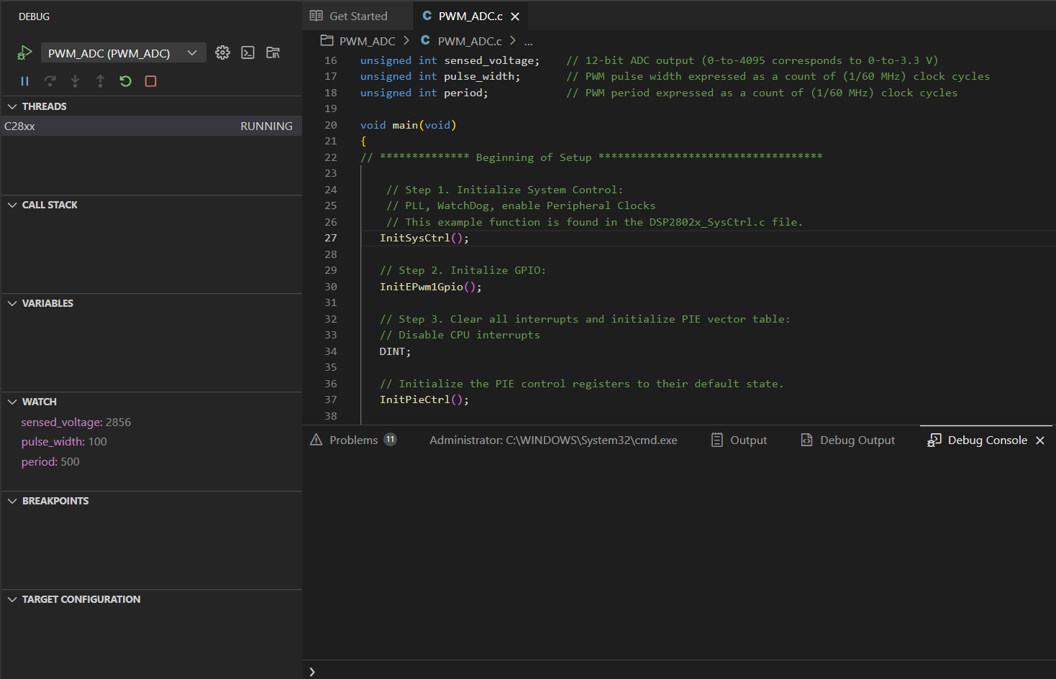
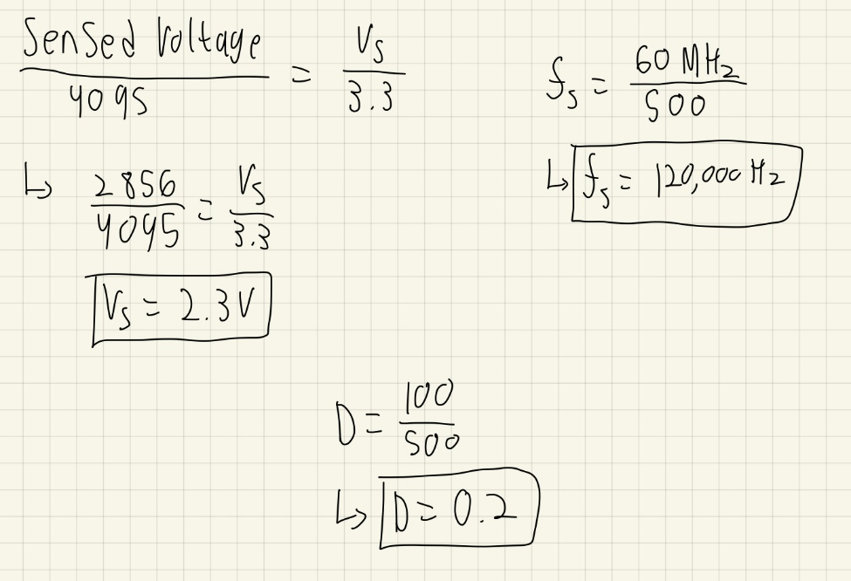
Using the values in the ‘Watch’ section in the code, I calculated Vs, Fs, and D above.

Step 9: 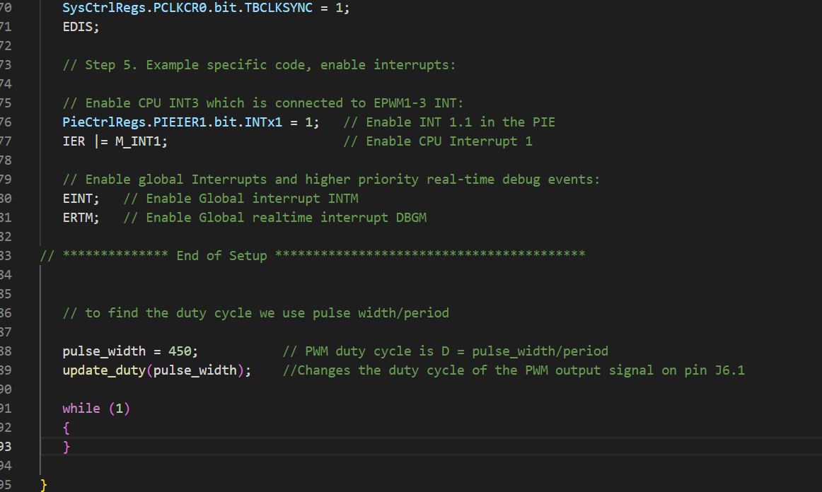
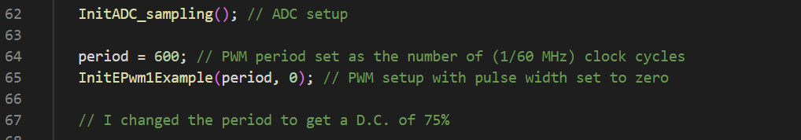
Setting pulse width as 450 and period as 600 will get the duty cycle of 75%

Step 10:
10%
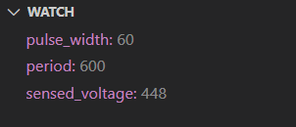
50%

90%

For the above I changed the pulse width to get duty cycles of 10%, 50% and 90%. Each changed the sensed voltage. For 10%, the Vs is 0.36 V. For 50%, the Vs is 1.67 V. For 90%, the Vs is 2.96 V.

